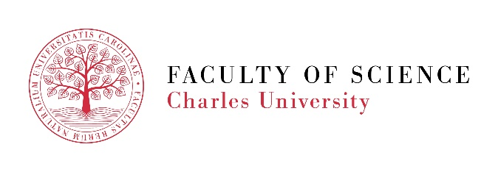

Researcher in the field of flow cytometry – a maternity and parental leave substitute job
Faculty of Science, Charles University, offers the position of a researcher in Imaging Methods Core Facility at BIOCEV (https://www.biocev.eu/imcf) as a substitute for a colleague on maternity and parental leave.

Work duties:
- Measurements on flow cytometer BD LSR Fortessa SORP + HTS
- Cell sorting on flow cytometer BD FACS Aria Fusion
- User training for independent operation of cytometer BD LSR Fortessa SORP + HTS
- User assistance in design, realization and analysis of flow cytometry experiments
- Routine upkeep of flow cytometers
- Upkeep of flow cytometry lab
- Participation at organization of educational courses
- Assistance with other duties related to the operation of core facility

Requirements:
- At least Bachelor or equivalent degree, preferentially in biosciences, medical sciences or technical field
- Basic computer skills
- basic knowledge of English in spoken and written form
- carefulness, manual skills and patience, willingness to learn new methods and procedures
- Prior experience with flow cytometry is an advantage
We offer:
- interesting and diverse work contributing to cutting-edge scientific projects
- modern and well-equipped workplace with experienced colleagues
- excellent working conditions and adequate pay
- complete training in flow cytometry
- Participation in Czech and international conferences and workshops

The position is offered in the range of 0.6 – 1 FTE. The place of work is Imaging Methods Core Facility, BIOCEV, Průmyslová 595, Vestec, Czech Republic.

We offer a contract for maternity and parental leave substitute period with three-month probation period. In the case of good performance, there is the prospect of a subsequent contract. The position may be suitable for students upon agreement.
The selected candidate can start the job immediately, but latest on 1.3.2020. An earlier start is preferred.
To apply, send your CV and a cover letter to email: libuse.vaneckova@natur.cuni.cz. Applications will be evaluated continuously until the position is filled.
If you have any other questions, please contact us at the email above.

